SS3 Quant Analysis Summary
Monday, May 20, 2019
5:52 PM

Technical Analysis

One population mean | Z-stats(known pop variance) / t-stats
Two population mean (independent) | T-stats
Two population mean (dependent) | Paired comparisons test (t-stats)
One population variance | Chi-square
Two population variance | F-stats

  - Time-series data consists of observations measured over a period of time, spaced at uniform intervals. The monthly returns on a particular stock over the last 5 years are an example of time-series data.
  - Cross-sectional data refers to data collected by observing many subjects (such as individuals, firms, or countries/regions) at the same point in time. Analysis of cross-sectional data usually consists of comparing the differences among the subjects. The returns of individual stocks over the last year are an example of cross-sectional data.
Data sets can have both time-series and cross-sectional data in them. Examples of such data sets are:
  - Longitudinal data, which is data collected over time about multiple characteristics of the same observational unit. The various economic indicators—unemployment levels, inflation, GDP growth rates (multiple characteristics) of a particular country (observational unit) over a decade (period of time) are examples of longitudinal data.
  - Panel data, which refers to data collected over time about a single characteristic of multiple observational units. The unemployment rate (single characteristic) o=f a number of countries (multiple observational units) over time are examples of panel data.

Sentiment indicators:
  - Put/call ratio {↑bad
  - Volatility index (VIX) {↑bad
  - Short interest ratio {↑bad
  - Margin debt {↑good
  - Opinion polls

Flow of funds:
  - Arms index
  - Short-term trading index (TRIN)

Price-based indicators:
  - Moving average lines
  - Bollinger bands: standard deviations above and below moving average
  - Momentum oscillators - relative strength index
    - rate of change oscillator: RSI, MACD(, moving average convergence/divergence), stochastic

Reversal patterns: head-and-shoulders, double top, triple top, inverse head-and-shoulders, double bottom, triple bottom
Continuation patterns: triangles, rectangles, flags, pennants

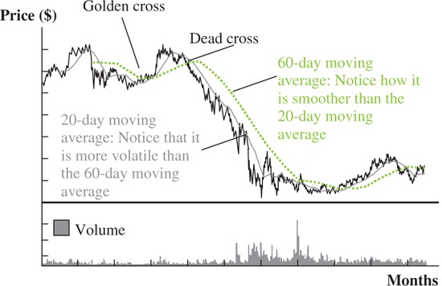

Time-weighted and Money-weighted
